



Solution Design Document

Data management

Version1.0

**January 31, 2019**

Document History

|  |  |  |  |  |
| --- | --- | --- | --- | --- |
| Revision | Description | Date | Prepared By | Reviewed By |
| 1 | Initial Draft | 22/01/2019 |  |  |

Table of Contents

1 Introduction 4

1.1 Document Purpose 4

1.2 In Scope 4

**1.3** **Out of Scope** 4

**1.4** **Relevant Documents (Current Situation/Environment)** 4

**1.5** **Assumptions** 5

**2** **Systems Overview** 5

**2.1** **Applications and Systems** 5

**2.2** **Applications Interfacing** 5

3 Analysis 6

3.1 High-level components 6

**3.2** **Narrative Use Case and Detailed Process** 6

**3.3** **Object Model Diagram** 7

7

4 Inputs and Outputs 8

4.1. Inputs 8

4.2. Outputs 8

5 Assets 8

**6** **Robot Schedule** 8

**7** **Workflow Modules** 8

1. Conversion Flow (Phase 1) 8

2. Employee ID present flow (Phase 2) 8

7.1 Exceptions 9

**8** **Logs** 9

**9** **RE-Framework Reusable Components:** 9

**10** **Coding Standards** 9

**11** **Frequency** 10

**12** **SLA** 10

**13** **Report Generation** 10

# Introduction

This document will provide solution design of Data Management.

## Document Purpose

The purpose of this document is to explain the solution design and overview for Data management Process

Its main purpose is to –

* Provide the link between the functional specification and the detailed technical design documents
* Detailed functionality provided by each component or group of components and show how the various components interact in the design
* Provide a basis for Rehire Eligibility Check detailed design and development
* This document is not intended to address installation and configuration details of the actual implementation. Installation and configuration details are provided in technology guides produced during project

As is true with any high-level design, this document will be updated and refined based on changing requirements.

## In Scope

* Internal Conversion & Camperforce
* External applicants with Emp ID’s

Happy Path:

Below applicants are eligible for Re-Hire

* Active employees currently working with Amazon
* Ex-Employees for Amazon without termination factor involved

Exceptional Flows:

*Exception flow will be updated once the clarification on the queries are received

* 1. **Out of Scope**
* Profiles without Employee ID’s
* Merging profiles
* RHE check during walk in process
* Any input format other than digital data from spreadsheet
  1. **Relevant Documents (Current Situation/Environment)**

The following documents are useful sources of information relevant to this design

|  |  |
| --- | --- |
| Document Name | Description |
| Rehire Eligibility Checks Discovery Package v2.xlsx | Process Flow and use cases were available in this spreadsheet |
| SOP - NAFC Rehire Eligibility Check 6.15.18.docx | Detailed process flow on the RHE process is explained in this document |

* 1. **Assumptions**
* VDI or machines will have the necessary applications (i.e. Outlook and Excel) installed
* Access to Peoplesoft and Salesforce will be provided
* The underlying applications does not undergo any change
* The credentials provided does not expire. In case if the credential expires, the user must update the same in Credential manager or in Orchestrator
* URL will not change. In case of any changes in the URL, the same must be updated in the orchestrator or in Configuration file

1. **Systems Overview****­­**

This Section depicts the Application/System being used in current process and what Application/System will be used after automation implementation.

* 1. **Applications and Systems**

|  |  |
| --- | --- |
| Applications | URL *(if any)* |
| Salesforce | Dev:  Test:  Prod: |
| PeopleSoft | Dev:  Test:  Prod: |
| Excel  Outlook | *Desktop application* |

**Type of access required – SSO, credentials etc.**

* 1. **Applications Interfacing**

|  |  |
| --- | --- |
| Applications/Systems | Interfacing mechanism |
| Salesforce | Through Robotic UI |
| PeopleSoft |
| Excel & Outlook |

# 

# Analysis

## High-level components

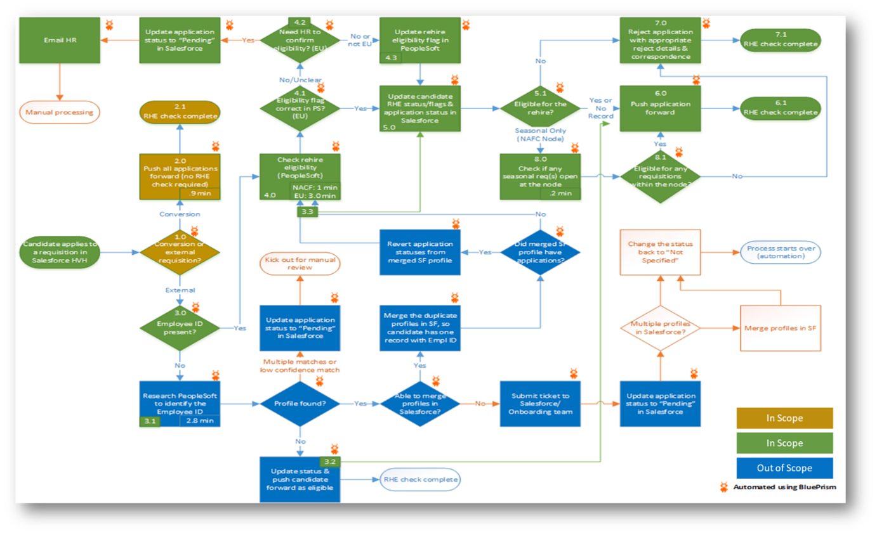

* 1. **Narrative Use Case and Detailed Process**

|  |  |
| --- | --- |
| Use Case Name | Rehire Eligibility Check |
| Goal in Context | Successful update in Salesforce application (Eligible for Re-hire and Not Eligible for Re-hire)  Notify candidates who are not eligible |
| Pre-conditions | Robot must have the relevant access to the Salesforce and PeopleSoft applications |
| Success End Condition | Robot will Update the Daily report with completion state |
| Primary Actor | BOT & Business User |
| Trigger | Scheduler created to run the Bot which gets triggered everyday morning |

* 1. **Object** **Model Diagram**

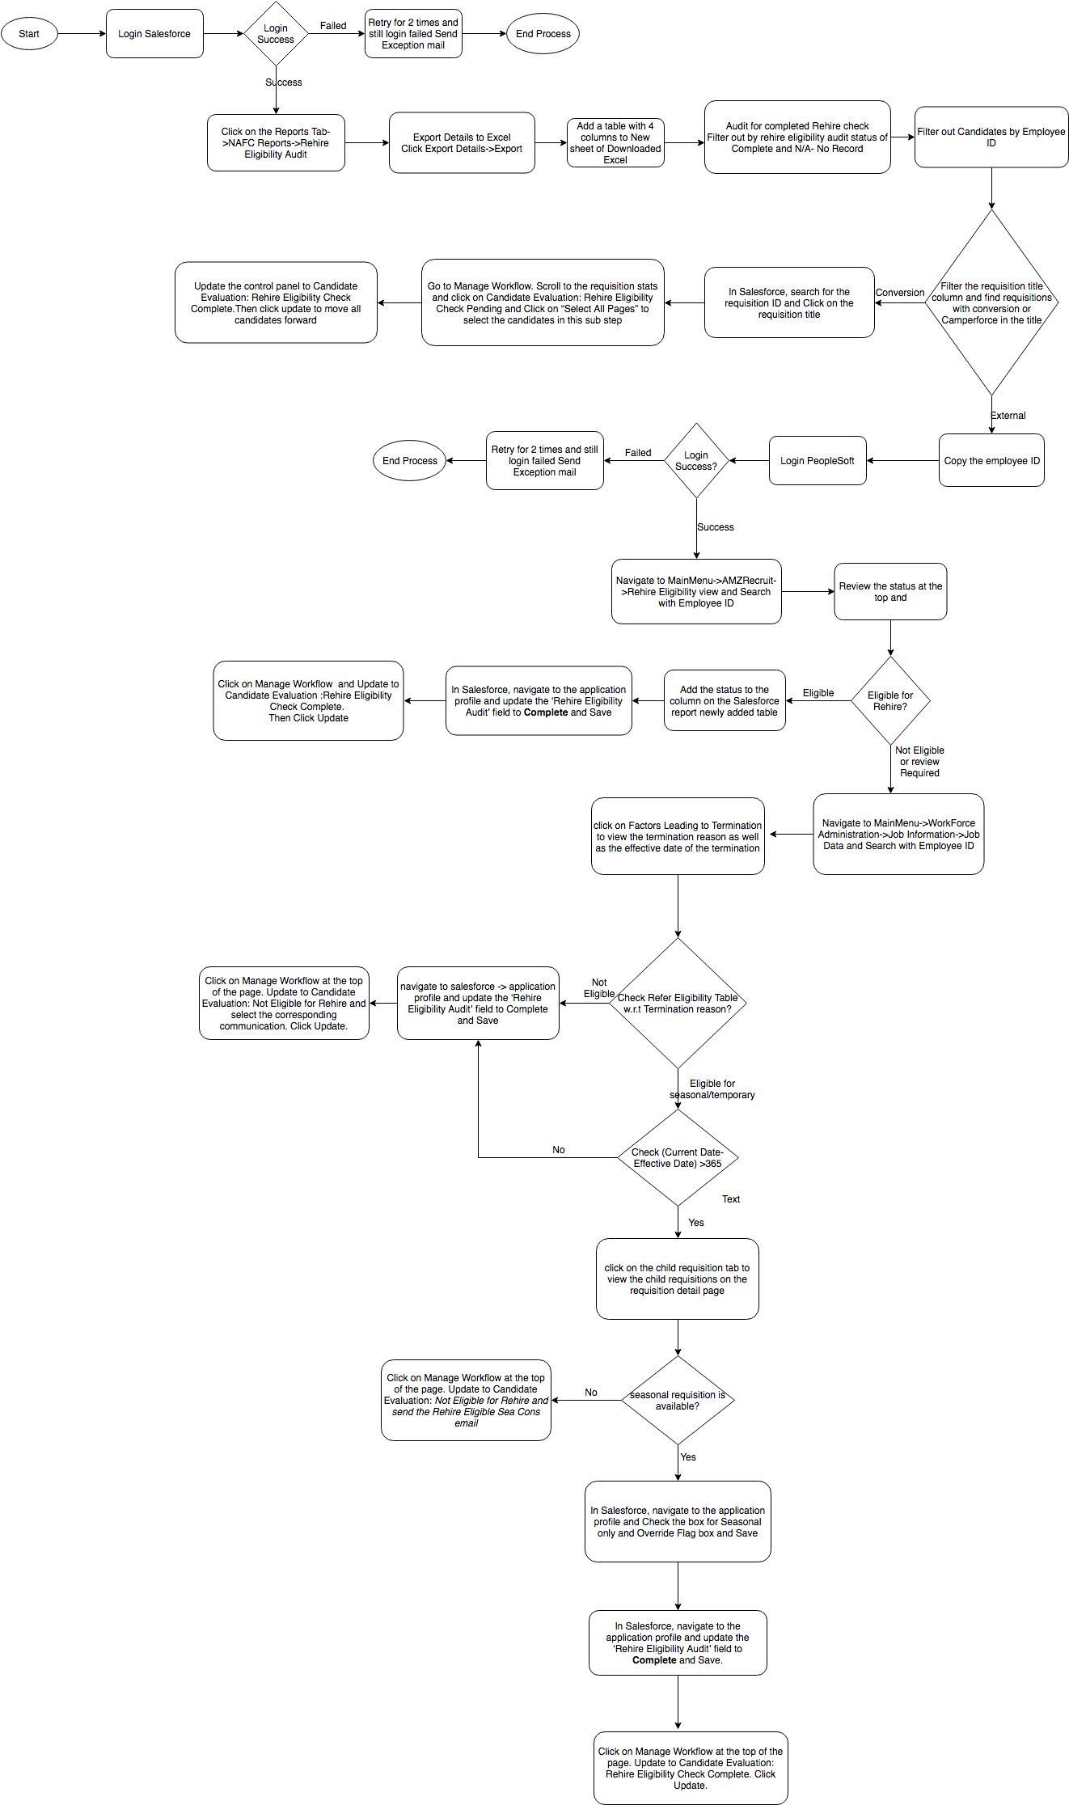

*Final Solution design will be ready once the clarification is received.

# Inputs and Outputs

## 4.1. Inputs

* Excel report downloaded from Salesforce

## 4.2. Outputs

* Update Rehire Eligibility Audit in Salesforce and update the Table in spreadsheet

# Assets  - Have a config file section and mention all these there

* Credentials for PeopleSoft
* Credentials for Salesforce

1. **Robot Schedule**

Robot will be scheduled to run for everyday morning.

1. **Workflow Modules**

**How many workflow / modules we create in Ui Path / Re-usable component**

## Conversion Flow (Phase 1)

* Login to Salesforce
* Download the Spreadsheet
* Filter the report
* Search Requisition in SF
* Click Req title
* Rehire Check Pending
* Select All Pages
* Change Substep to RHE Complete

## Employee ID present flow (Phase 2)

* Check Rehire Eligibility in PS
* Eligibility flag correct in PS?
* PS eligibility unclear (EU)/flag wrong - Reject for Exception – End
* PS eligibility corrected in PS
* Email HR
* Update candidate & application RHE status/flags
* Candidate eligible for rehire?
* Eligible - disposition application
* RHE check complete (eligible) – End
* Not Eligible - reject application
* RHE check complete (not eligible) – End
* Check if seasonal req(s) open
* Eligible for any request at this node?

## Exceptions

Description along with action (How BOT will behave in these cases)

|  |  |
| --- | --- |
| Exception | Description |
| Application Exception | Peoplesoft / Salesforce applications are down |
| Login to Peoplesoft / Salesforce fail |
| Business Exception | Yet to receive from the Client |

1. **Logs**

* Log information can be viewed from Orchestrator when the Bot is running in the system
* Log information will also be available in the following path – “C:\Users\’Bot Server or VDI’\AppData\Local\UiPath\Logs”
* Log files created by robot will be available in the shared directory

Transaction Log would have the following details

* Process Name
* Number of transactions received
* Number of transactions processed
* Number of transactions failed
* Process Start time
* Process End time
* AHT (Average Handling time)

Queue has to be mentioned here

1. **RE-Framework Reusable Components:**

* Framework\KillAllProcesses.xaml
* Framework\InitAllApplications.xaml
* Framework\GetTransactionData.xaml
* Framework\TakeScreenshot.xaml
* Framework\CloseAllApplications.xaml

1. **Coding Standards**

* Maintain proper folder structure
* Credentials can be accessed from credential manager or orchestrator
* Divide the process into number of modules based on application type and functionality
* Avoid hardcoded delays
* Avoid defaults/ constants
* Configurable variables/properties can be used from Configuration file or orchestrator
* Proper naming conventions for variables and sequences
* Handle exceptions for all negative scenarios
* Use log messages
* Close all the applications at the end

1. **Frequency – Put in Scheduling section**

* Once in a day
* Every 15 minutes, in case of Walk-in event scheduled for the day

1. **SLA- Put in Scheduling section**

SLA is to verify all the applications received on the same day (TBC)

1. **Report Generation**

The output report will be created on daily basis. The table structure provided by the client need to be updated with details of each candidate been processed for the day.